PU Smart Retail Analytics Database – Final Project Report

Student Information
Name: Mayank Vijayvargiya
Course: MBA
University: Parul University

Project Background
PU SmartMart is a retail chain operating both offline stores and an online platform across multiple cities. The company requires a centralized database system to track customers, products, categories, orders, payments and inventory. This system helps analyze sales performance, customer purchase behavior, inventory shortages and revenue trends.

Entities in the Database
Customers – Stores information about customers such as name, city, email and join date.
Categories – Stores product category information.
Products – Stores product details including price, stock quantity and launch date.
Orders – Stores order transactions made by customers.
OrderDetails – Stores products included in each order along with quantity and price.

ER Diagram
The following diagram represents the relationships between entities.

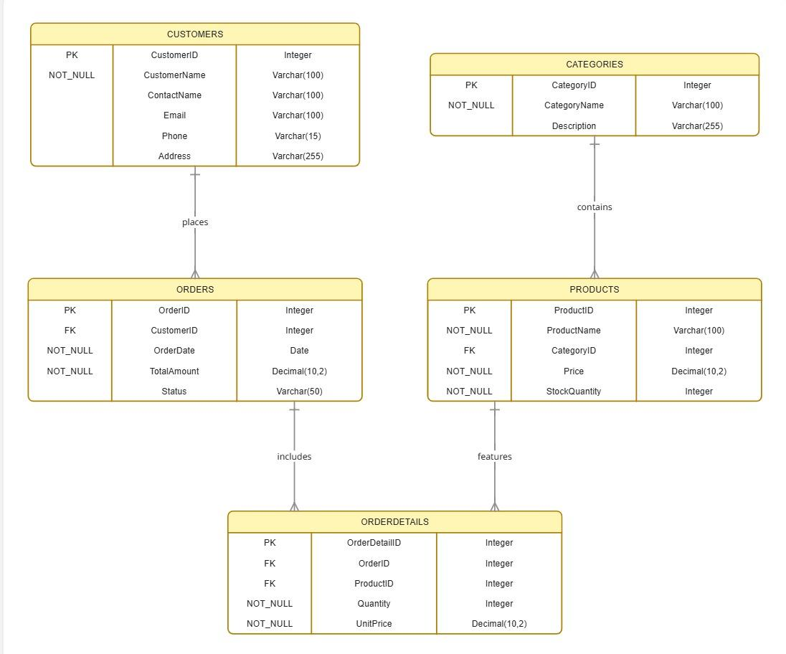

Business Insights
Based on the analytical queries executed on the dataset, the following insights were extracted:

A. Revenue & Market Performance
Highest Revenue Category: Electronics is the leading category by total sales value.
Geographic Concentration: Delhi is the primary market hub with the highest number of customers.
Loyalty Targets: The top-spending customers identified for loyalty programs are Rahul Sharma (70,000) and Vikram Joshi (45,000).

B. Inventory Health
Stock Alerts: The system identifies products with StockQty < 10 (e.g., Refrigerator, LED TV) for immediate restocking.
Rarely Sold Products: Items such as Smart Watches, Bookshelves, and Air Conditioners have zero sales recorded and may require marketing intervention

Conclusion
The PU Smart Retail Analytics database provides a structured system to manage customer data, product catalog, and order transactions. By using relational database design and SQL queries, the system helps businesses generate valuable insights for decision making.

